**1. Write a JavaScript to design a simple calculator to perform the following operations : sum, product, difference and quotient.**

**CODE :**

<!DOCTYPE html>

<html lang="en">

<head>

<meta charset="UTF-8">

<meta http-equiv="X-UA-Compatible" content="IE=edge">

<meta name="viewport" content="width=device-width, initial-scale=1.0">

<title>Calculator</title>

<style>

h1 {

text-align: center;

padding: 23px;

background-color: skyblue;

color: white;

}

#clear {

width: 270px;

border: 3px solid gray;

border-radius: 3px;

padding: 20px;

background-color: darkblue;

}

.formstyle {

width: 300px;

height: 530px;

margin: auto;

border: 3px solid blue;

border-radius: x;

padding: 20px;

}

input {

width: 20px;

background-color: lightblue;

color: lightcoral;

border: 3px solid gray;

border-radius: 5px;

padding: 26px;

margin: 5px;

font-size: 15px;

}

#calc {

width: 250px;

border: 5px solid black;

border-radius: 3px;

padding: 20px;

margin: auto;

}

</style>

</head>

<body>

<h1>Simple Calculator For Mathematical Operations</h1>

<div class="formstyle">

<form name="form1">

<input id="calc" type="text" name="answer">

<input type="button" value="1" onclick="form1.answer.value+='1'">

<input type="button" value="2" onclick="form1.answer.value+='2'">

<input type="button" value="3" onclick="form1.answer.value+='3'">

<input type="button" value="+" onclick="form1.answer.value+='+'">

<br><br>

<input type="button" value="4" onclick="form1.answer.value+='4'">

<input type="button" value="5" onclick="form1.answer.value+='5'">

<input type="button" value="6" onclick="form1.answer.value+='6'">

<input type="button" value="-" onclick="form1.answer.value+='-'">

<br><br>

<input type="button" value="7" onclick="form1.answer.value+='7'">

<input type="button" value="8" onclick="form1.answer.value+='8'">

<input type="button" value="9" onclick="form1.answer.value+='9'">

<input type="button" value="*" onclick="form1.answer.value+='*'">

<br><br>

<input type="button" value="/" onclick="form1.answer.value+='/'">

<input type="button" value="0" onclick="form1.answer.value+='0'">

<input type="button" value="." onclick="form1.answer.value+='.'">

<input type="button" value="=" onclick="form1.answer.value=eval(form1.answer.value)">

<br>

<input type="button" value="Clear All" onclick="form1.answer.value=''" id="clear">

<br>

</form>

</div>

</body>

</html>

**OUTPUT :**

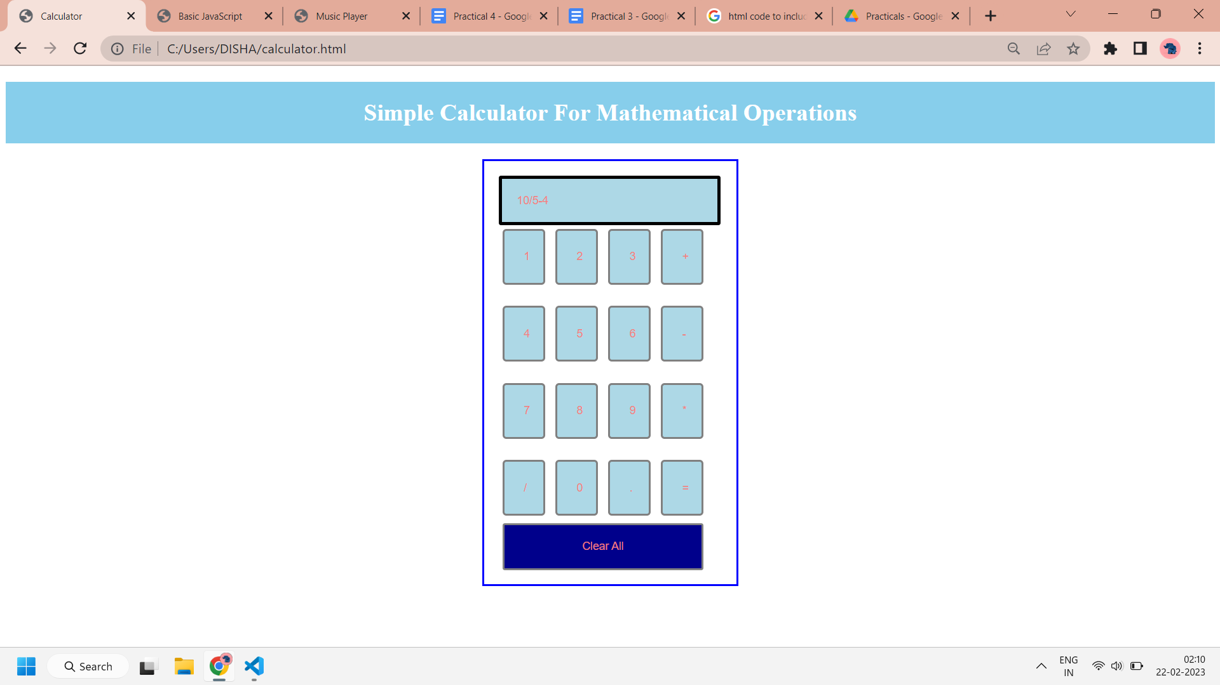

**2. Write a JavaScript that calculates the squares and cubes of the numbers from 0 to 10 and outputs HTML text that displays the resulting values in an HTML table format.**

**CODE :**

<!DOCTYPE html>

<html lang="en">

<head>

<meta charset="UTF-8">

<meta http-equiv="X-UA-Compatible" content="IE=edge">

<meta name="viewport" content="width=device-width, initial-scale=1.0">

<title>Basic JavaScript</title>

<script type="text/javascript" src="index.js"></script>

<link rel="stylesheet" href="styletable.css">

</head>

<script>

document.write('<p><b>SQUARES AND CUBES FROM 1 TO 10</b></p>');

document.write('<table border="2" cellspacing = "2">');

document.write('<th>Number</th><th>Square</th><th>Cube</th>');

for (var i = 1; i <= 10; i++) {

document.write('<tr><td>' + i + '</td><td>' + i * i + '</td><td>' + i * i * i + '</td></tr>');

}

document.write("</table>");

</script>

<style>

p {

text-align: center;

}

table {

border: solid black;

margin: auto;

}

td {

border: solid black;

text-align: center;

border-collapse: collapse;

width: 33%;

}

body {

font-family: 'Times New Roman', Times, serif;

font-size: 25px;

background-color: lightblue;

color: rgb(255, 123, 0);

}

</style>

</html>

**OUTPUT :**

